**DAILY ONLINE ACTIVITIES SUMMARY**

|  |  |  |  |  |  |  |  |  |
| --- | --- | --- | --- | --- | --- | --- | --- | --- |
| **Date:** | **02/06/2020** | | | | | **Name:** | **Archana J C** | |
| **Sem & Sec** | **4th**  **‘A’** | | | | | **USN:** | **4AL18CS011** | |
| **Online Test Summary** | | | | | | | | |
| **Subject** | | **No test was conducted** | | | | | | |
| **Max. Marks** | |  | | **Score** | | |  | |
| **Certification Course Summary** | | | | | | | | |
| **Course** | **Step into Robotic Process Automation** | | | | | | | |
| **Certificate Provider** | | | **Guvi** | | **Duration** | | | **3hours** |
| **Coding Challenges** | | | | | | | | |
|  | | | | | | | | |
| **Status: Completed** | | | | | | | | |
| **Uploaded the report in Github** | | | | | **Yes** | | | |
| **If yes Repository name** | | | | | **archana_j_c** | | | |
| **Uploaded the report in slack** | | | | | **Yes** | | | |

Certification Course Details: (Attach the snapshot and briefly write the report for the same)

COURSE NAME : **Step into Robotic Process Automation**

CERTIFICATION PROVIDERS : Guvi

Its of 3hours duration and I got an idea about RPA(Robotic Process Automation.

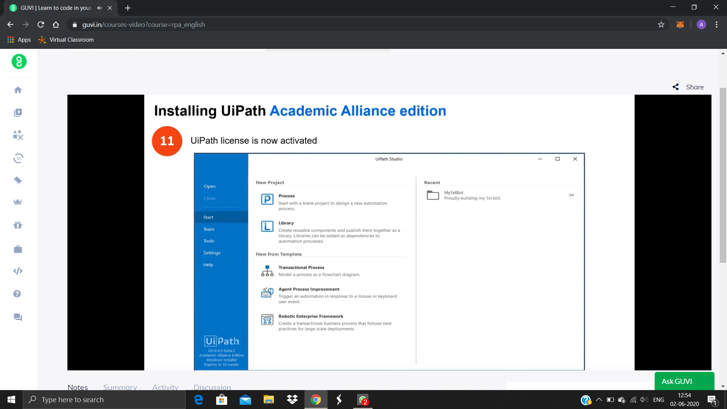

Coding Challenges Details: (Attach the snapshot and briefly write the report for the same)

Today I’m done with some java programs. The solution are already uploaded in github repository

